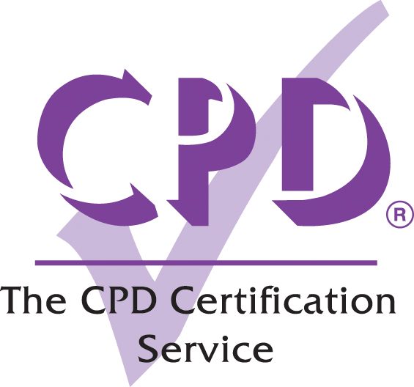

Self-assessment Record

To be completed by those wishing to record further learning and knowledge enhancement for Continuing Personal and Professional Development (CPD) purposes

SUBJECT/FORMAT/DATE:..........................................................................…………….

..................................................................................................................................................

1. What were the key issues covered and the learning benefits noted?

.......................................................................................................................................
.......................................................................................................................................

2. What can I put into practice by way of action points?
A) Immediately?
.......................................................................................................................................
.......................................................................................................................................

B) Medium/long term?

.......................................................................................................................................

..........................................................................................................................………

3. What further reading/research do I need to do?

.......................................................................................................................................
.......................................................................................................................................

4. Approximate study / further learning time achieved……............................................

NB: This form may be photocopied and retained amongst your personal CPD records. Completed photocopies might also be submitted by those required to forward documentary evidence of CPD activity to their professional association or institute.

