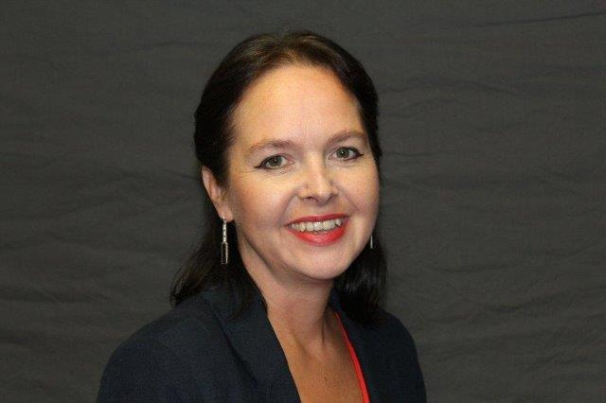

Dawn Chamberlain, Clinical Improvement Director

Dawn is the Clinical Improvement Director at NHS England and NHS Improvement which includes RightCare, the Beneficial Changes Network and Clinical Audit.
Dawn is an experienced and highly effective Executive Director; she was previously the London Productivity Director at NHS Improvement and Chief Operating Officer at South West London & St Georges Mental Health NHS Trust from 2012 – 2017. Dawn is passionate about making a difference for people and improving quality in the NHS.
Dawn’s extensive career in the NHS has included managing complex integrated systems across Mental Health and Social Care, Substance Misuse, Primary Care, Community Services and Acute Hospital settings.
Dawn began her career as an occupational therapist and holds a BSc in Occupational Therapy and an MSc in Addictive Behaviour.

