Joanna Doyle
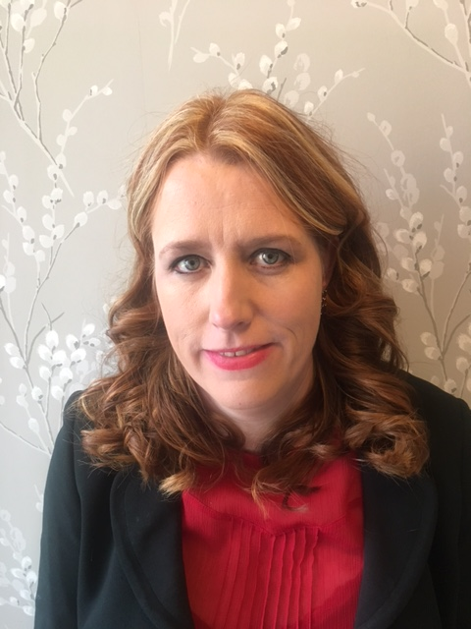
Head of All Wales Nurse Staffing Programme, Health Eduction Improvement Wales

Joanna qualified as a Paediatric nurse in 1995 and has a degree in Nursing, a degree in Childrens Community Nursing, a PGCE and an MSc in Advanced Nursing Practice. During her career of 26 years Joanna has worked within a wide range of Paediatric hospital and community environments and fulfilled senior management roles.
As head of the All-Wales Nurse Staffing Programme, Joanna co-ordinates the allied programmes of work, ensuring that stakeholders are appropriately engaged and informed, and provides direct support to the All-Wales Nurse Staffing Group, work stream leads and Health Boards/NHs Trusts across Wales in the development and delivery of the All Wales Nurse Staffing programme. She has presented a local, national and international conferences, showcasing the groundbreaking work that has been undertaken by NHS Wales in delivering the All Wales Nurse Staffing Programme and meeting the requirements of the Nurse Staffing Levels (Wales) Act.
Joanna is passionate about nursing and is committed to raising the profile of nursing, highlighting the importance of ensuring Wales has the right number and skill mix of nursing staff to deliver high quality care to patients and support the nursing workforce through a multi-faceted approach.
Contact details: Joanna.doyle2@wales.nhs.uk
Tel: 07901568365.

